TEST CASES

1. No occasion selected- Redirects to gifts.html → shows alert: **“Please select an occasion on the homepage first.”** and redirects back(CORRECT)

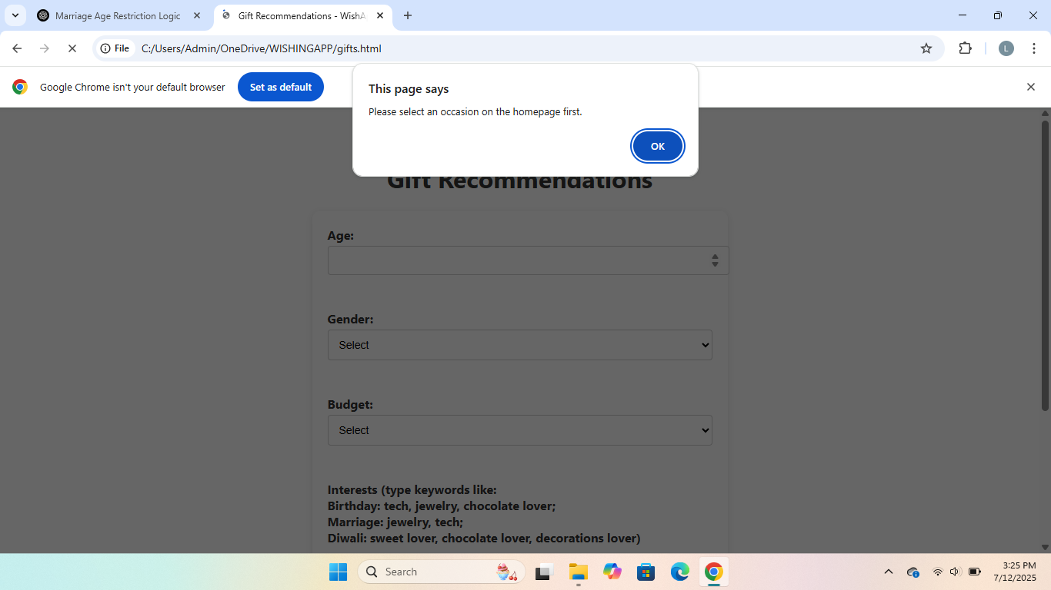

1. Valid occasion selected - Redirects to giftSrecommendation with occasion selected.(correct)

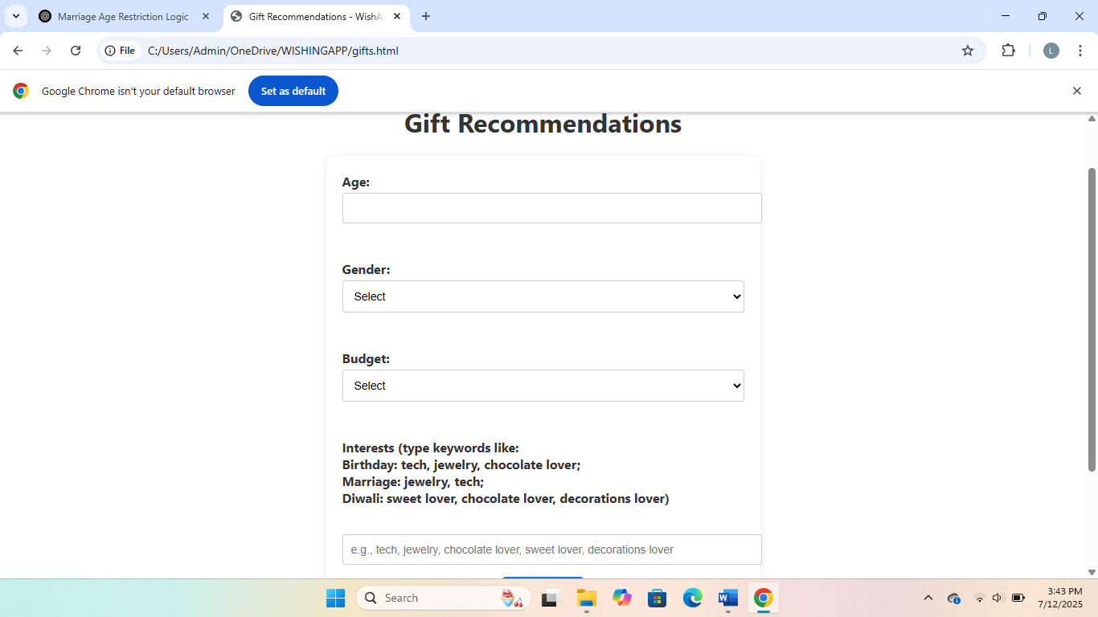

1. Missing gender - HTML validation blocks form submission(correct)

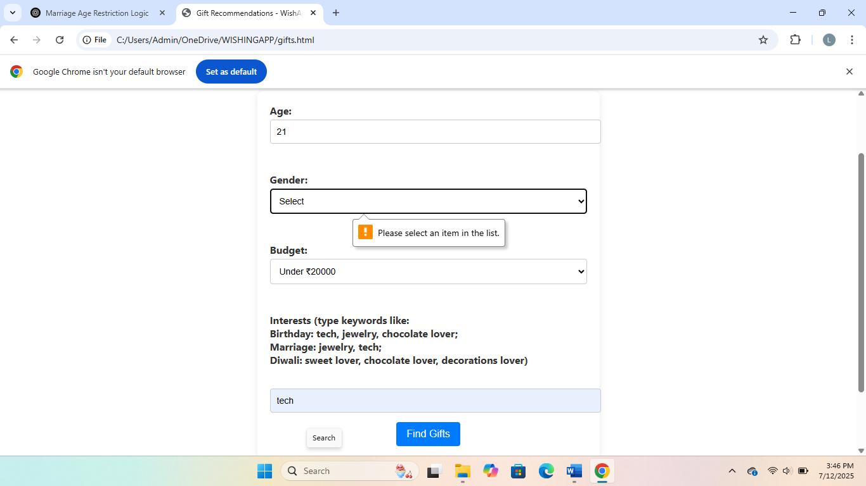

1. Missing age-HTML validation blocks form submission(correct)

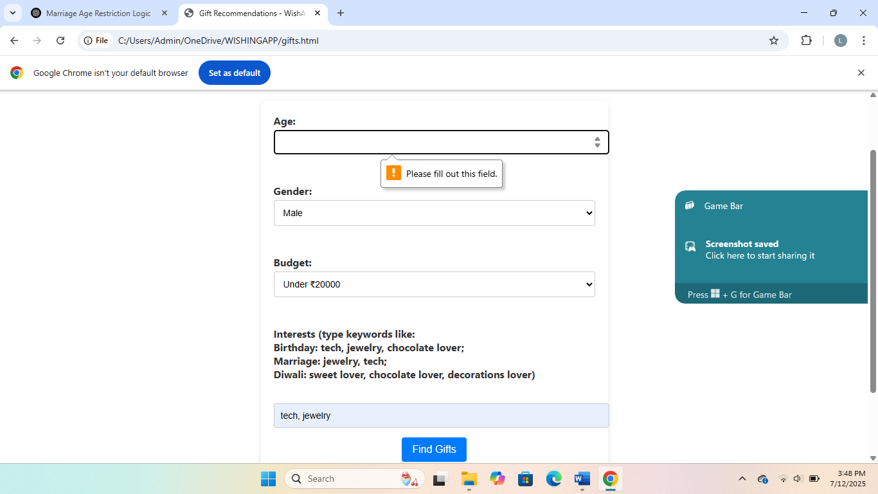

1. Invalid age for male or female in marriage - Shows: **"The age entered was invalid. Marriage gift recommendations are only allowed for males 21+ and females 18+"(Correct).**

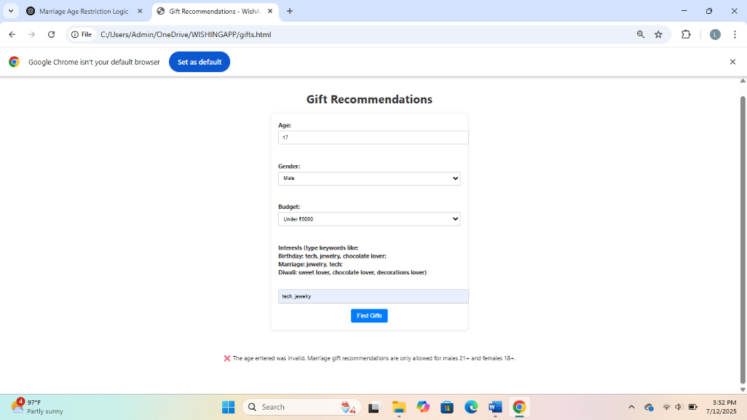

1. Valid marriage age - Gifts appear(Correct)

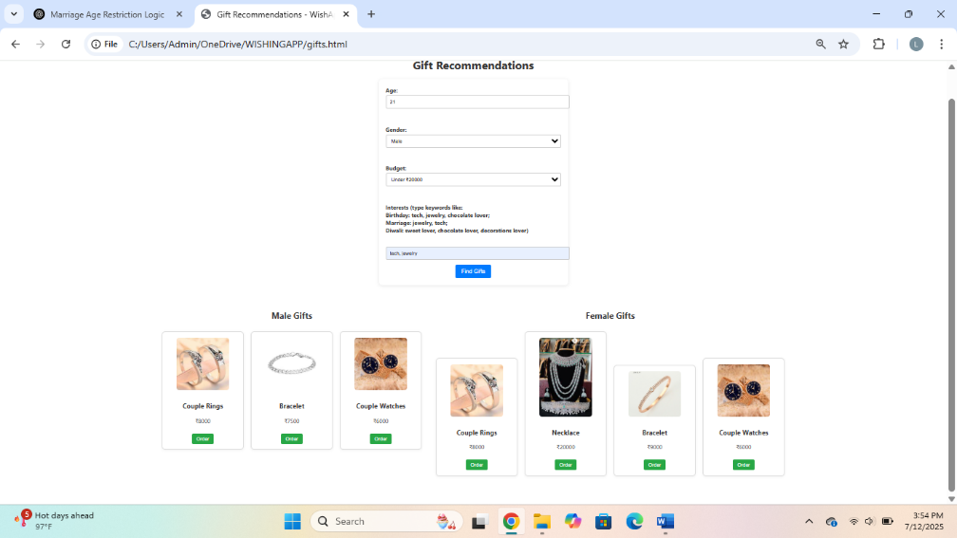

1. Interest not matching categories- Message: "No gifts matched your preferences."(Correct)

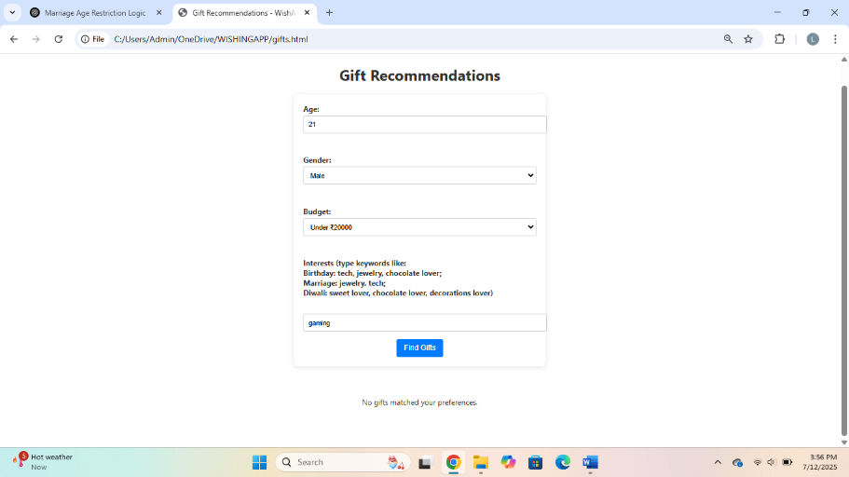

8)Budget too low - Message: "No gifts matched your preferences."(Correct)

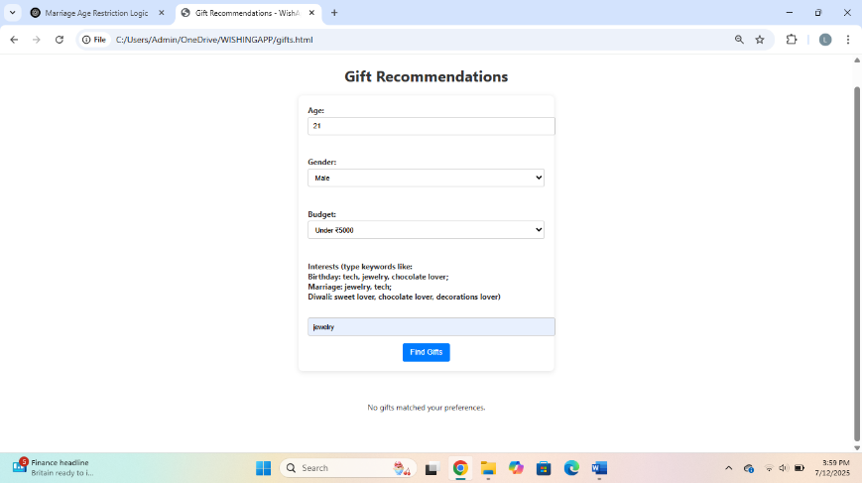

9)Valid Diwali interest - Gifts like sweets shown(Correct)

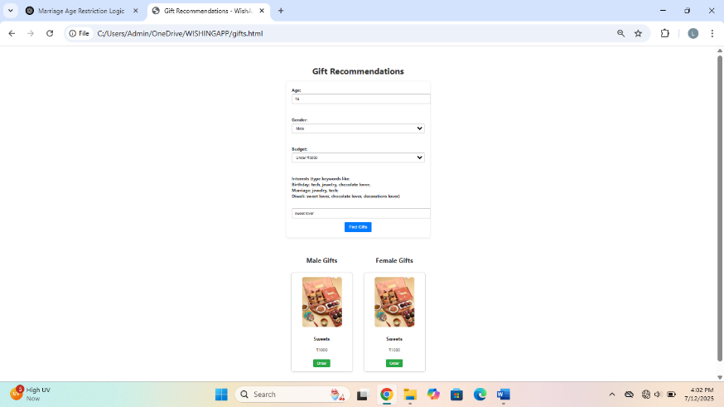

10)Gift card display - Cards show with image, price, and “Order” button(Correct)

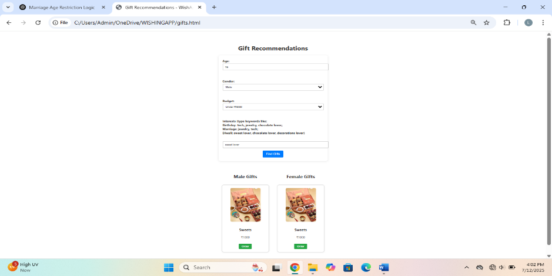

11)Order button works - Redirects to order.html(Correct)

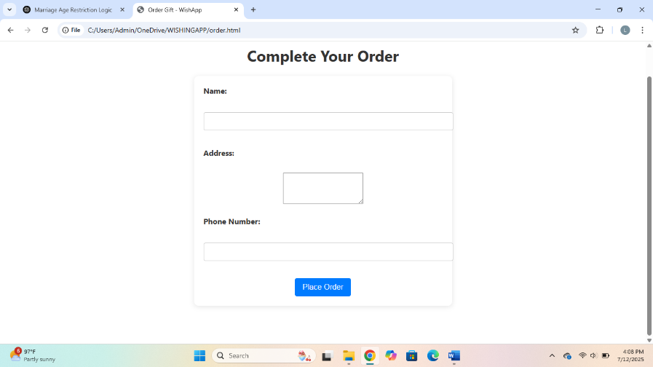

12)All fields valid(Name, Address, 10-digit phone) - Shows confirmation message

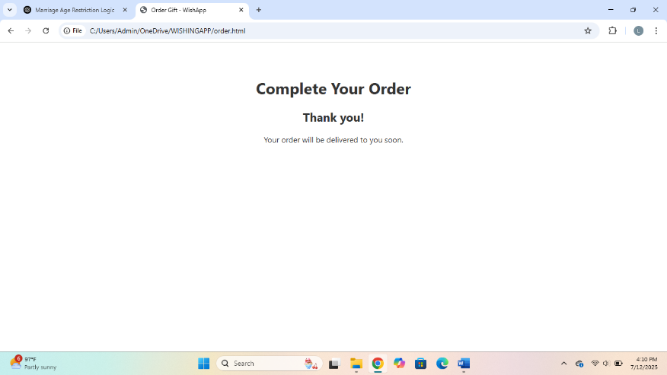

13)Invalid phone - Blocked due to pattern mismatch

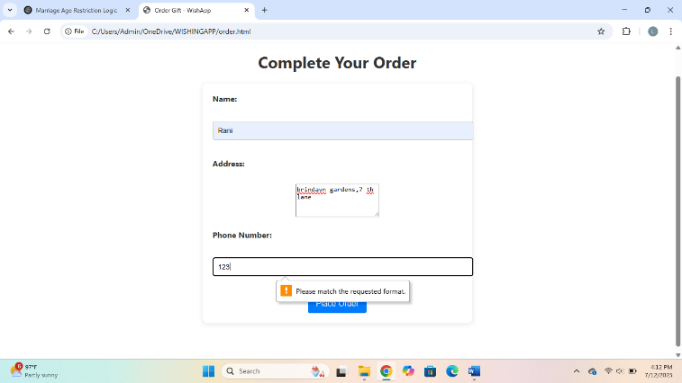

14)Missing fields(Leave address or name blank) - HTML validation blocks submission

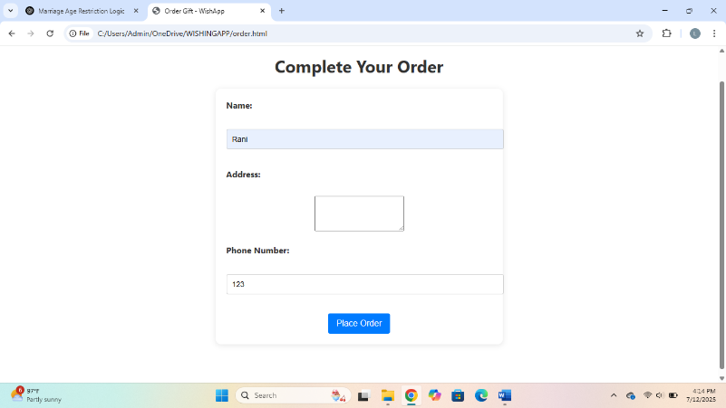

15)Non-numeric age - Browser prevents submission due to type="number"

